SEO Campaign
Content Review

Nimble Needle Tailoring

CAMPAIGN DETAILS


START DATE: February 2025
END DATE: February 2026

SEO: $1000/m

Blogs help SEO by keeping content fresh, targeting keyword themes for content development, facilitating internal linking, building authority, and more.

Please review the following blog(s) and accompanying image(s):



BLOG #3

The Most Common Suit Alterations and Why They Make a Difference

A well-fitted suit is more than just a fashion statement; it’s a reflection of confidence, professionalism, and attention to detail. Whether you're dressing for a wedding, a job interview, or a formal event in Ottawa, the fit of your suit can make or break your overall look. That’s where suit alteration comes in. Even the finest off-the-rack suits often need a few tweaks to achieve that perfect fit. Here are the most common suit alterations and why they matter.

1. Jacket Sleeve Length Adjustment
One of the most noticeable aspects of a suit jacket is the sleeve length. Ideally, your shirt cuff should peek out about half an inch from the jacket sleeve. If the sleeves are too long or too short, it throws off the balance of your entire outfit. Adjusting sleeve length is a relatively simple alteration that can dramatically improve your suit’s appearance.

2. Taking in or Letting out the Jacket
The torso of a suit jacket should contour to your body without being too tight or too loose. If your jacket feels boxy or pulls across the chest, it may need to be taken in. Conversely, if it feels snug, letting it out slightly can restore comfort and mobility. This alteration helps create a flattering silhouette and ensures the jacket complements your frame.

3. Pant Hemming
Pant length is crucial for a polished look. Whether you prefer a full break, half break, or no break at all, hemming your suit pants ensures they fall cleanly over your shoes. Unhemmed or overly long pants can look sloppy, while pants that are too short can affect your overall look. Hemming is one of the most common and essential suit alterations.

4. Tapering the Pant Legs
Modern suit styles often favour a slimmer, more tailored leg. If your suit pants feel too wide or outdated, tapering the legs can give them a more contemporary and flattering shape. This alteration is especially popular among younger professionals and those looking for a sleek, streamlined look.

5. Waist Adjustment on Pants
Comfort and fit go hand in hand when it comes to suit pants. If your waistband feels too tight or too loose, a simple adjustment can make a world of difference. A properly fitted waist ensures your pants stay in place and look sharp throughout the day, whether you're sitting, standing, or moving around.

Why These Alterations Matter

Suit alterations aren’t just about style; they’re about making your suit work for you. Here’s why each adjustment can make a meaningful difference:

- Improved Fit
A tailored suit hugs your body in all the right places, enhancing your natural shape and eliminating excess fabric that can look sloppy.
- Enhanced Comfort
Alterations ensure your suit moves with you, whether you're sitting through meetings or dancing at a wedding.
- Professional Appearance
A well-fitted suit communicates attention to detail and professionalism, helping you make a strong impression in any formal setting.
- Modern Style
Updating the cut of your suit, like tapering pant legs or slimming the jacket, can give older pieces a fresh, contemporary look.
- Longevity of Garments
Proper alterations can extend the life of your suit by preventing wear and tear caused by poor fit, such as stretched seams or frayed hems.
- Confidence Boost
Last, but not least, a perfect fit can make you feel more confident, which can be especially important in formal events and professional settings where first impressions matter most.

Ready to Elevate Your Suit Game?

If you have a suit that doesn’t quite fit the way it should, don’t let it sit in your closet. At Nimble Needle Tailoring, we specialize in high-quality suit alterations for all fabrics and styles. Our expert tailors in Ottawa are here to help you achieve the perfect fit, whether it’s a minor tweak or a major transformation. Contact us today to schedule your consultation and experience the difference precision tailoring can make.

Blog Image

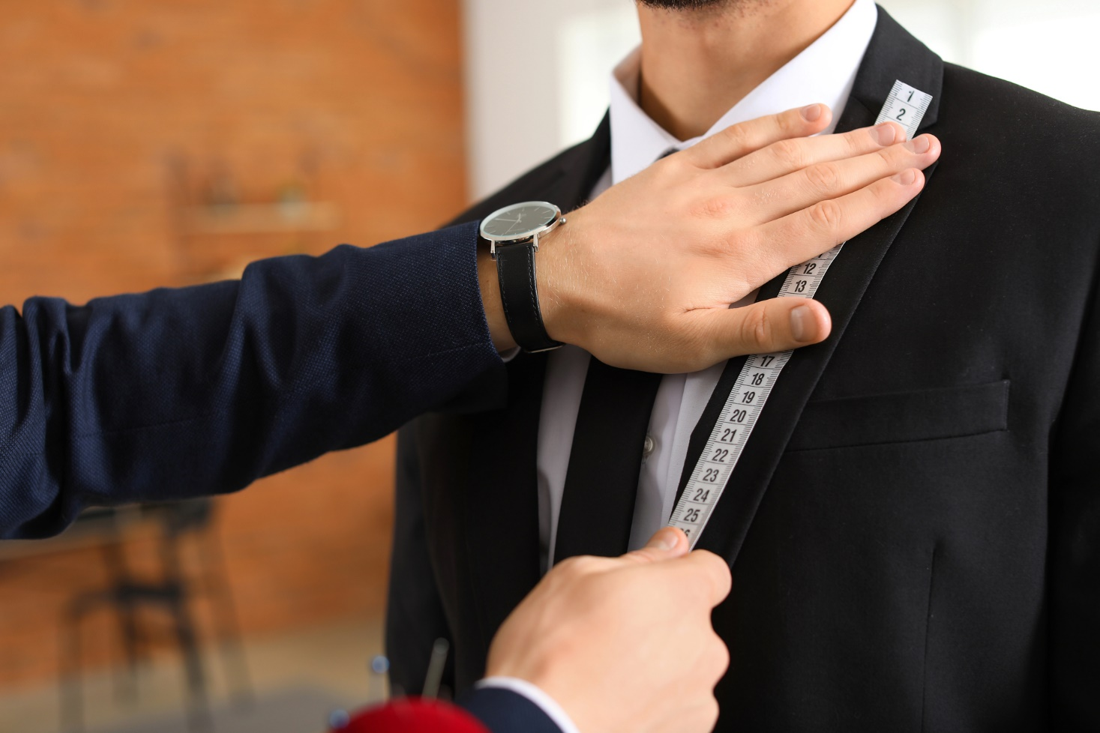

Optimization elements to be added to the backend of your website
Page Title | Suit Alteration | Nimble Needle Tailoring
Meta Description | Discover the most common suit alteration types and why they matter. Nimble Needle Tailoring in Ottawa ensures your suit fits flawlessly. Reach out to us!
Image Alt Tag | Male tailor taking client's measurements in atelier


WEBSITE CONTENT UPDATES

Regular content updates help keep your website relevant, optimized for search engines, and engaging for visitors. By incorporating current keyword themes, you can improve rankings, attract more traffic, and align with what people are actively searching for.
Please review the following content updates:

Please note, any text highlighted in yellow represents new or refreshed content.

PAGE URL: https://nimbleneedle.ca/

Title: Professional Tailoring & Clothing Alterations in Ottawa
Text: Your one-stop shop for all your tailoring, seamstress, and clothing alteration needs in Ottawa! No appointment needed.
Button: Contact Us
Button: View Services

Trusted Seamstress in Ottawa
Nimble Needle Tailoring offers professional seamstress services in Ottawa, with two convenient locations: our established shop on Preston Street and our new shop on Riverside Drive. From business suits to formalwear and everyday garments, our team provides careful alterations designed for comfort, fit, and long-term wear. Contact our seamstress today and experience tailoring that’s crafted to fit you flawlessly.

Services

Experience Our Hassle-free Clothing Services
We are Ottawa’s premier destination for tailoring and alteration solutions, delivering skilled craftsmanship and personalized service across a broad range of needs. Our service offerings include:

- Tailoring – Offering custom adjustments to refine the fit of any garment with precision and care.
- Custom-made and retail suits – Helping you look your best, whether you're selecting off-the-rack or commissioning a bespoke suit.
- Dry cleaning – Providing professional cleaning to keep your garments fresh, clean, and well cared for.
- Clothing alterations – Adjusting and tailoring everyday and formal wear to ensure comfort and style in every stitch.
- Prom dress alterations – Delivering flawless fits and elegant finishes so you look flawless on your special night.
- Wedding dress alterations – Professionally reshaping bridal gowns for comfort and a flawless walking-down-the-aisle moment.
- Seamstress services – Offering skilled sewing and repair services to bring your clothing—and creative visions—back to life.
- Suit alterations – Fine-tuning the fit of suit jackets and trousers to enhance both comfort and silhouette.
- Dress and skirt alterations – Adjusting length, shape, and waistlines for a beautifully tailored silhouette.
- Pants alterations – Precisely hemming and reshaping trousers for your ideal fit and finish.
- Jacket alterations – Tailoring structure and proportions in jackets to complement your build perfectly.
- Shirt alterations – Refining sleeves, collars, and overall fit to elevate your everyday or dress shirt.
- Zipper repair and replacement – Restoring functionality fast with reliable zipper fixes you can trust.

Our Promise
We are proud to be an Ottawa company that delivers top-quality services to our clients. Our family-run business can meet your needs for clothing alterations, repairs and custom sewing for clothing and other textiles. With high-quality work, quick turnaround times, and friendly service, we've earned the trust of hundreds of highly satisfied customers.

[Learn More]

Craft

The Craftsman Ship
At our tailoring studio, we pride ourselves on delivering high-quality craftsmanship with quick turnaround times, all while providing friendly, personalized service. No appointment needed - we offer fixed, clear pricing and handle all fabrics and styles. Our commitment to excellence has earned us the trust and satisfaction of countless happy customers.

[Learn More]

Why Choose Us

Experience the Nimble Needle Tailoring Difference
Discover what makes our tailoring services exceptional:

Meet with Us
Call or visit our location to review your needs. No need for an appointment. We can provide you options if needed and give you a fixed, clear cost for the work.

Sit Back and Relax
Let our clothing professionals work on your items quickly and efficiently to get the results you'll love, in the timeframe you need.

Text Notifications
Get notified by text as soon as your order is ready for pickup.

Locations

Visit Us at Our Two Convenient Ottawa Locations
We're here to serve you better with two locations across Ottawa:

Testimonials
See what our clients say about us:

Frequently Asked Questions
Below are some of the most commonly asked questions about our seamstress services in Ottawa:

Do I Need to Book an Appointment?
Nimble Needle Tailoring welcomes walk-in clients at both locations. Simply bring your garments during our opening hours.

What Are Your Business Hours?
Our store is open Tuesday through Saturday, 9:00 AM—9:00 PM, and Sunday through Monday, 10:00 AM—7:00 PM.

Can I Drop off Multiple Garments at Once?
Clients are welcome to bring several items for alteration during a single visit.

CTA
Title: Ready to Experience Our Exceptional Service?
Text: Walk in with your garments and let our seamstresses take care of the rest.
[Contact Us]

CTA
Title: Your Trusted Seamstress in Ottawa
Text: Bring your garments to Nimble Needle Tailoring and let us handle your alterations. Walk in today.
[Call Today]

CTA
Title: Our Services
Text: From suit alterations to everyday clothing adjustments, we provide professional solutions for all your garment needs.
[View Our Services]

Latest from Our Blog
Tips, insights, and advice on tailoring and garment care:

[View All Blog Posts]

Optimization elements to be added to the backend of your website
Page Title | Seamstress Ottawa | Nimble Needle Tailoring
Meta Description | Seamstress services are available at Nimble Needle Tailoring in Ottawa. Visit our Preston or Riverside locations for professional suit and garment alterations.

NEW PAGE CONTENT
Creating a new page allows you to focus on a specific keyword theme, making it easier for search engines to understand your content and improve visibility. This targeted approach helps drive more organic traffic and increases the chances of turning visitors into customers.
Please review the following new page content:

PAGE URL: https://nimbleneedle.ca/suit-alterations

Suit Alterations

Professional Suit Alterations in Ottawa
At Nimble Needle Tailoring, we provide reliable suit alterations in Ottawa for clients seeking precise and professional tailoring. With convenient locations in Preston and our new Riverside store, our team strives to ensure every suit fits comfortably and presents a polished appearance that meets professional and personal standards. Get in touch with us today for the right fit.

Looking for Suit Alterations to Get a Perfect Fit?
Get the perfect fit for your business suits, formal wear, and special occasion attire. Our reliable tailors ensure your suits fit like they were custom-made for you. We ensure:

- Perfect fit guarantee.
- All suit types.
- Professional results.
- Quick turnaround.
- Proudly serving Ottawa.

[Book an Appointment]
[Call Us]

Call to get your questions answered or visit our shop. No appointment necessary. Walk-ins welcome!

Benefits of Professional Suit Alterations
Choosing a trained tailor ensures your garment keeps its original shape and quality while being adjusted for comfort and style. Professional alterations provide:

- Accurate fit: Measurements are taken precisely to match your body shape.
- Long-lasting results: Proper techniques maintain fabric strength and suit structure.
- Refined look: A polished finish that makes your suit appear custom-made.
Professional tailoring gives you confidence that your suit will look sharp and feel comfortable for any occasion.

Our Suit Alteration Processes
At Nimble Needle Tailoring, our team handles a variety of suit alteration processes, including:

- Hemming trousers to the correct length.
- Adjust the jacket waist and sides.
- Shortening or lengthening sleeves.
- Refining shoulder fit and overall jacket structure.

Each clothing alteration is completed with precision to preserve the suit’s craftsmanship and achieve a tailored fit. Our process includes assessment, adjustment, and review, with refinements made as needed. We provide professional suit alterations in Ottawa, and we ensure that every garment meets client expectations.

Excellent 819 reviews

Common Customer Needs We Address
Our services are designed to accommodate customer needs with care and precision.

I have questions
Not sure what alterations your suit needs? Our team can assess the fit and recommend the best adjustments!

I need it done right
We specialize in suit alterations with precision tailoring to ensure the perfect professional fit.

I have an urgent need
Need your suit altered for an important meeting or event? We offer rush services to meet your deadline!

Testimonials
Find out what our clients are saying about us:

Frequently Asked Questions
Below are some of the most frequently asked questions about our custom suit alterations in Ottawa:

How Do I Know What Alterations My Suit Needs?
Our team at Nimble Needle Tailoring can evaluate your suit and recommend the adjustments required for the best fit. We provide professional guidance to ensure your garment sits comfortably and looks well-tailored.

Can You Ensure My Suit Is Tailored Correctly?
We specialize in suit alterations, performing precise tailoring to achieve a professional and accurate fit while preserving the suit’s original craftsmanship.

Do You Offer Urgent or Rush Services?
If you need your suit ready for an important meeting or event, we provide rush alteration services whenever possible. Customers can discuss their timeline with our team, and we aim to complete adjustments promptly without compromising quality.

CTA
Title: Ready to Experience Our Exceptional Service?
Text: Visit us today at our Preston or Riverside location and experience precise, professional suit alterations.
[Stop by Today]

Optimization elements to be added to the backend of your website
Page Title | Suit Alterations Ottawa | Nimble Needle Tailoring
Meta Description | For precise suit alterations in Ottawa, visit Nimble Needle Tailoring at Preston or Riverside. Walk in today and leave with a suit tailored to your fit.

